Revolutionizing Cancer Treatment : The Role Of Nanoparticles In Drug Delivery

Chaitra Gouda1, Gowri Bharadwaj HP2, Nagalakshmi S³, S Swetha Vaisshnavi⁴, Sindhushree M2

1 (M13) , 2(M22) , ³(M45) , ⁴(M60) UG BE Dept. of ECE

2 Assoc. Prof., ECE Dept., Dayananda Sagar College of Engineering, Bangalore

Dayananda Sagar College of Engg., Bangalore, Karnataka

Email: chaitragouda1809@gmail.com1 Email: dr.pavithrag.8984@gmail.com2

***Abstract***— **Nanoparticles have gained significant attention in recent years as a promising approach for drug delivery. The unique physicochemical properties of nanoparticles enable them to improve drug solubility, target specific cells or tissues, provide controlled drug release, protect drugs from degradation or elimination, and reduce toxicity to healthy cells. These advantages have made nanoparticles a valuable tool in drug delivery for a wide range of diseases. Nanoparticles can be designed to target specific cells or tissues in the body, improving drug efficacy while reducing side effects. The increased solubility of drugs facilitated by nanoparticles allows for better delivery and efficacy of drugs that have poor solubility in water. Controlled drug release from nanoparticles provides sustained drug delivery, reducing the need for frequent dosing and improving patient compliance. Furthermore, nanoparticles can protect drugs from degradation or elimination, increasing their effectiveness. Overall, the usage of nanoparticles in drug delivery systems holds great potential for improving patient outcomes and revolutionizing the field of medicine. This abstract provides an overview of the potential applications of nanoparticles in drug delivery systems[1].**

***Keywords***— **Drug delivery, Nanoparticles, Targeted delivery, Controlled release, Solubility, Biocompatibility, Invitro-invivo studies, Safety, Regulatory approval**

1. Introduction

Nanoparticles are ultra-small particles, typically between 1 and 100 nanometers in size, that have unique properties due to their small size and high surface area-to-volume ratio. These properties make nanoparticles attractive for a wide range of applications, including drug delivery. Drug delivery systems based on nanoparticles involve using these tiny particles to transport therapeutic agents to specific sites in the body. This approach has several advantages over traditional drug delivery methods, such as improving drug solubility, increasing drug bioavailability, and allowing for targeted drug delivery. Nanoparticles have emerged as a promising technology for drug delivery due to their unique physicochemical properties, such as small size, large surface area, and high reactivity. These properties enable nanoparticles to efficiently encapsulate and deliver drugs to target cells and tissues, thereby improving the therapeutic efficacy and reducing the side effects of drugs. Drug delivery systems are technologies designed to deliver therapeutic agents, such as drugs or biologics, to a patient's body in a safe, controlled and effective manner, while reducing the side effects and minimizing the risk of toxicity[2].

There are several types of nanoparticles that can be used for drug delivery, including liposomes [small spherical vesicles composed of a non-toxic phospholipid bilayer that can encapsulate both hydrophobic and hydrophilic drugs (25nm-50nm)], polymeric nanoparticles [nanoparticles composed of biocompatible polymers that can encapsulate drugs (nano capsules or nanospheres) which can be engineered to release drugs in controlled manner, which allows for sustained drug delivery over a longer period (10nm-100nm)], dendrimers [highly branched, tree-like, multi layered, monodisperse, and symmetrical nanoparticles that can encapsulate drugs in their interior. They have high drug loading capacity (1nm-20nm)], carbon nanotubes [ hollow cylindrical structures composed of carbon atoms that can encapsulated drug inside their interior. They have a high surface area and can be functionalized with targeting ligands (1nm-100nm)], and metallic nanoparticles like gold nanoparticles [nanoparticles composed of dielectric core and metal shell(gold) that can be functionalized by targeting ligands or imaging agents. They have unique optical properties that make them attractive for imaging and sensing applications (<75nm)]. Each type of nanoparticle has its own advantages and disadvantages in terms of drug delivery[3]. Drug delivery systems can take many forms, such as nanoparticles, micelles and implants through various modes like oral, nasal(shown in fig. 1), topical, transdermal and injection formulations. In drug delivery systems, nanoparticles can be designed to improve the pharmacokinetic properties of drugs by enhancing their bioavailability, solubility, and stability. Nanoparticles can also be functionalized with targeting ligands or surface modifiers to enable specific interactions with cells or tissues, thereby improving the selectivity and efficiency of drug delivery. The use of nanoparticles in drug delivery has been explored for a variety of diseases, including cancer, infectious diseases, and neurological disorders. Nanoparticles have shown promising results in preclinical and clinical studies, and several nanoparticle-based drug delivery systems are currently under development or in clinical use[4]. However, there are also challenges and concerns associated with the use of nanoparticles in drug delivery, such as toxicity, biocompatibility, and regulatory issues. Therefore, extensive research and development are required to optimize the design and safety of nanoparticle-based drug delivery systems. Overall, nanoparticles have the potential to revolutionize drug delivery by improving the efficacy and safety of drugs while reducing their side effects. Ongoing research in this area is focused on developing more efficient and targeted drug delivery systems that can be used to treat a wide range of diseases

1. SCOPES AND OBJECTIVES

The scope for nanoparticles in drug delivery systems is vast and promising. Nanoparticles can be designed to deliver a wide range of drugs. Nanoparticles can be engineered to be small enough to cross these barriers and deliver drugs directly to the site of action. Nanoparticles also offer the potential for controlled and sustained release of drugs, which can improve patient compliance and reduce the need for frequent dosing. The unique properties of nanoparticles offer numerous advantages over traditional drug delivery systems, including improved bioavailability, targeted drug delivery, and reduced toxicity. These advantages make nanoparticles an exciting area of research and development in the field of drug delivery.

The objective of this topic is to provide a comprehensive overview of the use of nanoparticles in drug delivery systems. It aims to educate the reader on the types of nanoparticles used in drug delivery, the advantages they offer over conventional drug delivery systems, and the challenges faced in their development. Additionally, it aims to highlight the potential of nanoparticles to revolutionize drug delivery and improve patient outcomes.

1. PROPOSED METHODOLOGY & BLOCK DIAGRAM

The synthesis of nanoparticles can be achieved using various methods, such as chemical precipitation, emulsion polymerization, and sol-gel synthesis. The choice of method depends on the desired properties of the nanoparticles and the type of drug to be delivered. Methodology in drug delivery system involves several steps like ; Selection of appropriate nanoparticles: The first step is to selection of nanoparticles that can be made from various materials such as lipids, polymers, metals, and ceramics. The choice of nanoparticles depends on factors such as the type of drug, tumor type, and the intended route of administration; Surface modification of nanoparticles: Once the nanoparticles are selected, they need to be modified to target tumor cells. This can be achieved by attaching targeting moieties such as antibodies, peptides, or aptamers on the surface of the nanoparticles. This modification allows the nanoparticles to specifically bind to tumor cells and minimize off-target effects; Formulation of nanoparticles: The selected nanomaterials are then formulated to encapsulate the therapeutic agents, such as chemotherapy drugs, gene therapies, or small interfering RNA (siRNA). The formulation can be done using various techniques such as emulsion, solvent evaporation, nanoprecipitation, etc.; Characterization of nanoparticles: The nanoparticles are characterized for their size, shape, surface charge, drug loading efficiency, drug release kinetics, and stability; Characterization of nanoparticles: This is to ensure their quality and performance. This can be achieved by analyzing parameters such as particle size, zeta potential, drug loading efficiency, and release kinetics; Toxicity evaluation: The toxicity of the nanoparticles is evaluated using appropriate toxicity studies such as acute toxicity, sub-chronic toxicity, and genotoxicity studies[6]; Encapsulation of drugs: The next step is to encapsulate the drug within the nanoparticles. The drug can be loaded into the nanoparticles by various methods such as physical entrapment, adsorption, or covalent attachment. The amount of drug loaded in the nanoparticles should be optimized to achieve maximum therapeutic effect; Targeting: Nanoparticles can be designed to target specific cells or tissues, such as cancer cells. This can be achieved by modifying the surface of the nanoparticles with ligands that bind to receptors or other molecules on the surface of the target cells. Once the nanoparticles bind to the target cells, they can be taken up by endocytosis, allowing the drug to be delivered specifically to the target cells; Controlled release: Nanoparticles can be designed to release drugs in a controlled manner, either by diffusion or degradation of the nanoparticle matrix[7]. These nanoparticles loaded with drug can be released by external way too through; Magnetic targeting, Ultrasound-triggered release, Photo-triggered release, Electric fields.

For example, nanoparticles can be engineered to release drugs in response to a stimulus such as temperature, pH, or enzyme activity. This allows the drug to be released in a specific location or over a specific time period, improving the drug's therapeutic efficacy while minimizing side effects.

Protection: Nanoparticles can protect drugs from degradation by enzymes or other factors in the body. For example, nanoparticles can be designed to shield the drug from the immune system, allowing it to remain in circulation for longer periods of time. Additionally, nanoparticles can protect the drug from degradation in the acidic environment of the stomach or the harsh conditions of the liver.

In vitro and in vivo evaluation: The nanoparticles should be evaluated in vitro and in vivo to assess their efficacy and safety. In vitro studies can be conducted to evaluate the cellular uptake and cytotoxicity of nanoparticles. In vivo studies can be conducted in animal models to evaluate the biodistribution, pharmacokinetics, and therapeutic efficacy of nanoparticles[8]; Optimization and scale-up: Based on the results of in vitro and in vivo studies, the formulation should be optimized to improve its efficacy and safety. Once the optimized formulation is developed, it can be scaled up for further studies or clinical trials; Improved pharmacokinetics: Nanoparticles can improve the pharmacokinetics of drugs by increasing their circulation time in the body and reducing their clearance. This can improve the bioavailability of the drug and increase its therapeutic efficacy; Clinical trials: The efficacy and safety of the nanoparticles are evaluated in clinical trials. This involves testing the nanoparticles in a small group of patients to determine their efficacy, safety, and optimal dosage.

The release of the drug from the nanomaterial can be triggered by various stimuli, such as pH, temperature, enzymes or light, depending on the design of the nanoparticle.

For example, some nanoparticles are designed to release their contents in response to the acidic environment found in certain types of cancer cells like some nanoparticles are designed in such a way that they are neutral pH but release their contents when exposed to an acidic pH such as in tumor environment.Nanoparticle safety release can be externally controlled by some of the imaging techniques such as; Magnetic Resonance Imaging (MRI), Fluorescence imaging, Positron Emission Tomography (PET), Computed Tomography (CT) [9].

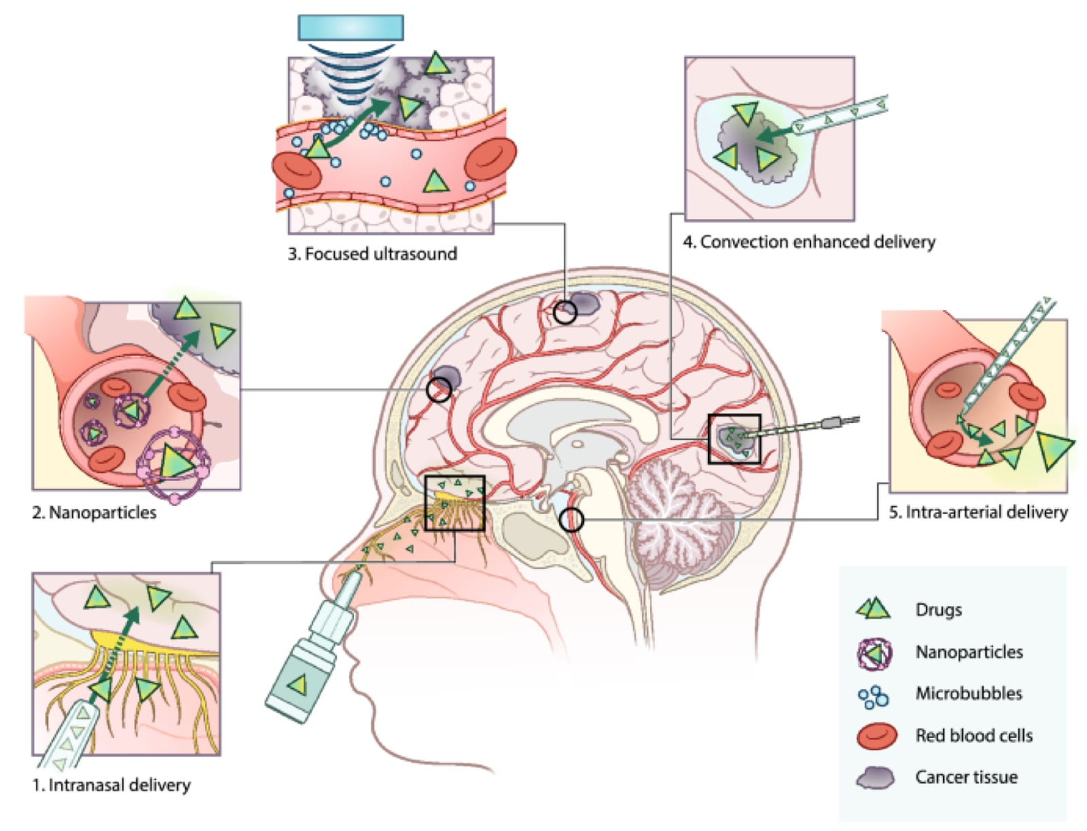

Figure 1. Current Drug Delivery Method For The Treatement Of Primary Brain Tumour : A Comprehensive Overview [9].

1. RESULTS

The use of nanoparticles in drug delivery systems has shown promising results in preclinical and clinical studies. Nanoparticles have been used to deliver a variety of drugs, including chemotherapeutic agents, peptides, proteins, and nucleic acids. They have been shown to enhance drug efficacy, reduce toxicity, and improve patient compliance. However, there are still challenges to be addressed, such as nanoparticle stability, reproducibility, and safety concerns. Nonetheless, the potential benefits of nanoparticle-based drug delivery systems make them an exciting area of research and development [10].

1. ADVANTAGES & APPLICATIONS

Nanoparticles in drug delivery system has numerous advantages over conventional drug delivery systems such as; Targeted drug delivery: Nanoparticles can be engineered to target specific cells or tissues, allowing for the delivery of drugs directly to the site of action. This can reduce the risk of adverse effects on healthy tissues and increase the efficacy of the drug; Controlled drug release: Nanoparticles can be designed to release drugs in a controlled manner, allowing for sustained drug release over an extended period. This can reduce the frequency of dosing and improve patient compliance; Protection of drugs from degradation: Nanoparticles can protect drugs from degradation by enzymes and other biological processes, thus increasing their stability and prolonging their shelf life; Reduced toxicity: Nanoparticles can reduce the toxicity of drugs by minimizing their exposure to healthy tissues and organs. This can improve the safety profile of drugs and reduce the risk of adverse effects; Improved drug solubility and bioavailability: Many drugs have poor solubility in water, which limits their therapeutic efficacy. Nanoparticles can encapsulate hydrophobic drugs and enhance their solubility in water-based solutions, thereby improving their bioavailability and therapeutic efficacy;[11] Multifunctional: Nanoparticles can be engineered to have multiple functions, such as targeting, imaging, and drug delivery, all in one system.

Nanoparticles offer a versatile platform for drug delivery with potential applications in a broad range of therapeutic areas such as; Cancer Treatment: Nanoparticles can be used to deliver chemotherapy drugs directly to cancer cells, minimizing damage to healthy tissue and improving therapeutic efficacy; Gene Therapy: Nanoparticles can be used to deliver genetic material, such as DNA or RNA, to target cells for the treatment of genetic disorders or other diseases; Immunotherapy: Nanoparticles can be used to deliver immune-modulating agents, such as cytokines or antibodies, to stimulate the immune system and fight infections or cancer; Vaccines: Nanoparticles can be used as carriers for vaccine antigens, improving their stability and efficacy; Anti-inflammatory Therapy: Nanoparticles can be used to deliver anti-inflammatory drugs to treat inflammatory diseases such as rheumatoid arthritis, Crohn's disease, and multiple sclerosis; Brain Delivery: Nanoparticles can be designed to cross the blood-brain barrier and deliver drugs for the treatment of neurological diseases such as Alzheimer's and Parkinson's; Wound Healing: Nanoparticles can be used to deliver growth factors and other therapeutic agents to promote wound healing.

1. Conclusions and Future Directions

In conclusion, the usage of nanoparticles in drug delivery systems represents a promising approach for effective treatment of a variety of diseases, including cancer. Nanoparticles can be engineered to target specific cells or tissues, increase drug solubility, control drug release, protect drugs from degradation or elimination, and reduce toxicity to healthy cells. These advantages make nanoparticles a valuable tool in drug delivery, as they improve drug efficacy while reducing side effects. Ongoing research continues to explore new ways to harness the unique properties of nanoparticles for drug delivery, and it is expected that this field will continue to expand and develop in the coming years. Overall, the usage of nanoparticles in drug delivery systems holds great potential for improving patient outcomes and revolutionizing the field of medicine.

References

1. de Villiers MM, Aramwit P, Kwon GS. Nanotechnology in drug delivery. New York: Springer; 2008.
2. Science Direct | Article | Ibrahim Khan; Khalid Saeed; Idrees Khan
3. Nanoparticulate Drug Delivery System | Slideshare | Mr. Sagar Kishore Savale
4. Jain A, Jain SK. Ligand-appended BBB-targeted nanocarriers (LABTNs). Crit Rev Ther Drug Carrier Syst. 2015;32:149–80.
5. Martinho N, Damgé C, Reis CP. Recent advances in drug delivery systems. J Biomater Nanobiotechnol. 2011;2:510.
6. Patra JK, Baek K-H. Green nanobiotechnology: factors affecting synthesis and characterization techniques. J Nanomater. 2014;2014:219.
7. Razzacki SZ, Thwar PK, Yang M, Ugaz VM, Burns MA. Integrated microsystems for controlled drug delivery. Adv Drug Deliv Rev. 2004;56:185–98..
8. Liu Z, Tabakman S, Welsher K, Dai H. Carbon nanotubes in biology and medicine: in vitro and in vivo detection, imaging and drug delivery. Nano Res. 2009;2:85–120.
9. Biomolecules | www.mdpi.com

online, <https://images.app.goo.gl/y5RZPUf6GNqd9FMn8> (fig. 1)

1. Jahangirian H, Lemraski EG, Webster TJ, Rafiee-Moghaddam R, Abdollahi Y. A review of drug delivery systems based on nanotechnology and green chemistry: green nanomedicine. Int J Nanomed. 2017;12:2957.
2. Thilakarathna SH, Rupasinghe H. Flavonoid bioavailability and attempts for bioavailability enhancement. Nutrients. 2013;5:3367–87